

Assertive Mentoring Policy

Policy Title | Assertive Mentoring Policy
Version | V1
Committee Approval | SLT
Approved | Yes
Date of Approval | September 2018
Review Frequency | Annually
Review Date | September 2019
Approved By : Headteacher | H Dunbavin
Approved By : Chair of Governors | N/A

Assertive Mentoring Policy

WHAT IS ASSERTIVE MENTORING?

Assertive Mentoring involves all children and all staff, all of the time. It is high status, driven by the leadership team and is the central activity to drive forward school improvement and pupil achievement. It is a process we use to track and drive rapid progress and achievement.

Assertive Mentoring provides the vehicle for ensuring the collection of systems which are brought together and wrapped around the child. The child remains central to the whole process throughout. Assertive Mentoring is a guaranteed, regular, one to one dialogue between pupil and mentor. It is evidence based and focused on;

- Attainment
- Achievement
- Attitude.

Progress towards long term targets is reviewed as well as the achievement of medium term targets. SMART targets are carefully chosen from agreed assessment criteria so as to be both challenging yet achievable and to have the greatest impact on performance. These targets transfer to pupils’ personal mentor files and form the focus of continual assessment, marking, feedback and support.

Its key components are:

- School Self Evaluation
- Data analysis
- School improvement planning
- Target Setting: long, medium and short term
- Pupil Tracking
- Intervention and support systems
- Monitoring
- Performance Management systems

Its key outcomes are:

- True Assessment for Learning
- A personalised curriculum
- Raised standards for all

It facilitates:

- Continual and consistent assessment
- Effective feedback to pupils and parents
- Pupil and peer-assessment
- Marking and feedback
- Home-school partnerships

PRACTICAL APPLICATIONS

Aims of Assertive Mentoring at Hope High School
- Staff to have a high standard of pupil expectation in all aspects of work.
- Staff to help raise the levels of pupils’ self-esteem.
- To provide a broad, balanced and differentiated curriculum
- To provide a varied range of teaching and learning styles to suit the needs of pupils.
- To provide an attractive learning environment and quality resources.
- To track pupil progress, set challenging thorough achievable targets and support children in achieving them.
- Children know their efforts are valued and that progress matters.
- To encourage children to accept varying degrees of responsibility, both in and out of the classroom with the purpose of promoting independence, self-reliance and trustworthiness.
- To make provision for pastoral care of children, with staff giving support and guidance to each individual child.
- To consistently and fairly implement reward and sanctions systems.
- To encourage school/parental partnership, to promote children’s education and maintain standards of behaviour.

TIMETABLE AND THE CURRICULUM

Assertive mentoring in Hope High School runs along-side the core curriculum subjects; English, Mathematics and Science, it provides a framework of basic skills support and assessment objectives for each of the core curriculum subjects which are taught and targeted throughout the year.

Levelled assessment criteria for reading, writing, maths and science are used for continual assessment and record keeping. They are designed to be easy to use and consistently applied. A class record for each level is restricted to one page and a simple coding system indicates whether the objective is partly, mostly or fully achieved.

Partly achieved | . | Mostly achieved | / | Fully achieved | X

This allows records to be updated by superimposing a line on a dot or changing a line to a cross. Using a different colour per term can also provide a visual indication of progress over the term or year. The consistency of this system allows records to be shared for intervention and moderation purposes and passed on to the next teacher the following year to ensure continuity.

MATHS

During one maths lesson per week, pupils complete a Weekly Basic Skills Test which is marked by the subject teacher. During weekly basic skills lessons, Big Maths, pupils are provided with the opportunity to address any issues highlighted in the weekly test through targeted and personalized learning which helps to close any gaps in mathematical knowledge and understanding. Pupils keep a record of their weekly skill test results in their own mentoring files, this is also used by staff for assessment for learning and to aid future planning.



Weekly Basic Skills Tests are not done under exam conditions. Pupils may be provided with prompt sheets to encourage independent inquiry and learning through their assessments.
There are 15 of these weekly assessments at every level and 15 at each bridging level. A pupil must achieve 4 weeks of marks in the green (above 20 marks out of 25) before they are allowed to move on to the next level or bridging level.

Pupil Prompt sheets (Stage 1-7) are used when doing the basic skills assessments or given as homework. The sheets show examples of how to answer questions against each APP criteria at every level. These are hugely powerful as once the pupils become familiar with the prompt sheets most can teach themselves. They are also an excellent revision resource.

The Pupil Tracking Sheet is the pupils’ tracking sheet for the year. The maths subject teacher provides dot, line cross results of marking the first of the six half termly tests. The subject teacher is first expected to baseline to provide a consistent and accurate assessment of where all your pupils are in relation to the assessment criteria at the level they are working at.
For example a child scoring 14 crosses would be assessed as a Stage 2 Developing and would require three more crosses to achieve a low Stage 2 Securing (17 crosses) as a step towards achieving an end of year target of a Stage 3 Ready The targets then form the focus for marking and feedback.

1-8: St 2 emerging | 9-16: St 2 developing | 17-24: St 2 securing | 25-30: St 3 ready

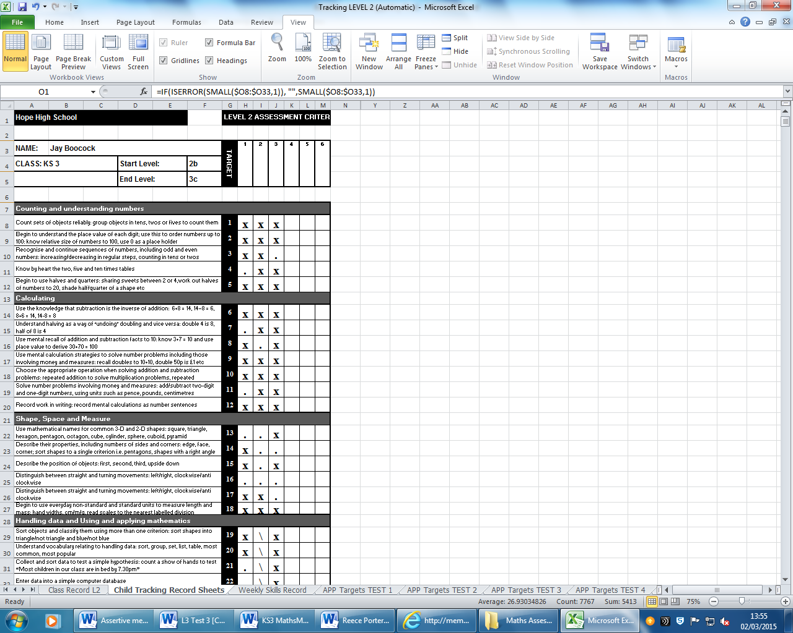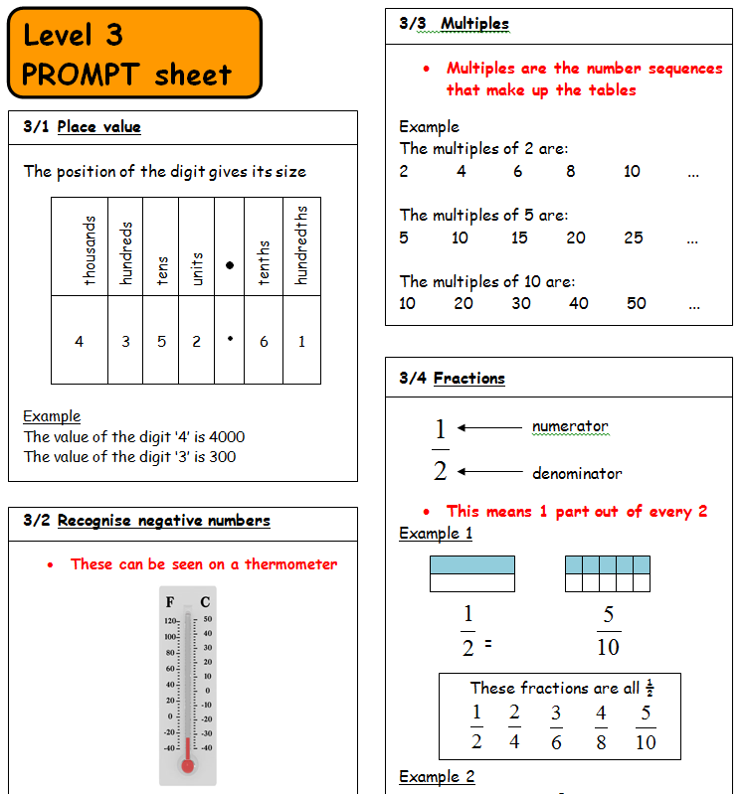

Pupil Personal Numeracy Target
The teacher sets targets for the pupil for the whole of the next half term by going to the lines on the pupil tracking sheet. This is because the pupils are closest to converting these into crosses already. The Numeracy target are referred to regularly and can be found on pupils Personal learning Plans (PLPs) and termly pupil assessments which are shared with home.

Maths Class Records are used by the maths subject teacher to easily and continually track pupil progress without having to refer to individual exercise books. They allow the teacher to maintain an overview of class performance and are particularly useful in identifying gaps in teaching or learning, which in turn informs planning. The teacher can see what impact his/her teaching has had, and can adapt plans to target gaps in understanding identified by the assessments. The scheme isn’t abandoned, just modified to address gaps in pupils’ learning as we teach the pupils not the scheme.

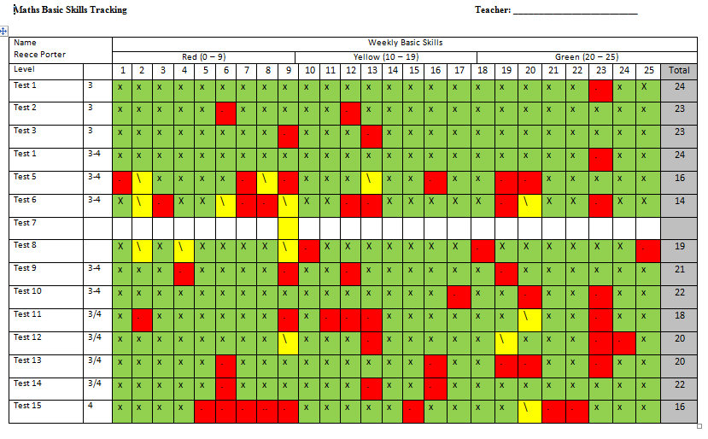

Half-term Maths Assessments

Half Term Tests are completed under exam conditions and take about an hour to complete. (Answer sheets are provided). If pupils get the question completely right the teacher awards a cross on the pupil’s tracking sheet; if only partially right….a line; completely wrong…. a dot. If they don’t even attempt the question, leave it blank. The teacher then adds up the crosses and records the number in the space at the bottom of that column. This number is used to identify which sub stage the result places the pupil in and where they lie within the sub stage. This is printed and given to the pupils as their record. It is re-printed for pupils every half term after each new half termly test results in an update. A clear picture builds over the year, increasing the evidence base and therefore teacher confidence in the accuracy of the stage assigned. It also provides pupils an opportunity to show they have mastered their targets and that they haven’t forgotten any prior learning.

There are six termly assessments for each Stage 1-7

Score each section separately and enter in the appropriate box on the cover sheet. This gives an indication of areas of particular strength or weakness which in turn should inform the breath and balance of teaching.

A (7): B (7): C (10): D (7): Total Score (31): rade:

A(2) B(5) C(11) D(18) E(10) Total Score (46) Grade

Each question is ordered and cross referenced to individual maths assessment criteria for the
appropriate test level e.g. 1 mark (G/4) indicates Grade G/Assessment Criteria 4.

Example: Grade 2 Test 1
4. Shade  of this shape.
1 mark (L2/4)

Understand and use simple fractions; ½, ¼, ⅟₃, ⅟₅, ⅟₁₀, those that are several parts of a whole; ¾, ⅖ and recognise some fractions that are equivalent to ½ = ⁵⁄₁₀ etc | 4

As well as tracking the marks they are getting, if the pupil gets the question completely correct you put a cross in the cell next to that criteria on the Child Tracking Sheet; partially right a line; if it’s plain wrong, a dot. Add up the crosses once you have completed the process and use the bottom row on the Child’s Tracking Sheet to award the sub stage they are working at. Don’t use the marks to award the sub stage. It’s useful to have the marks though since a pupil may not move up a sub stage/grade yet they may have made good progress nonetheless and they can see this through their mark.

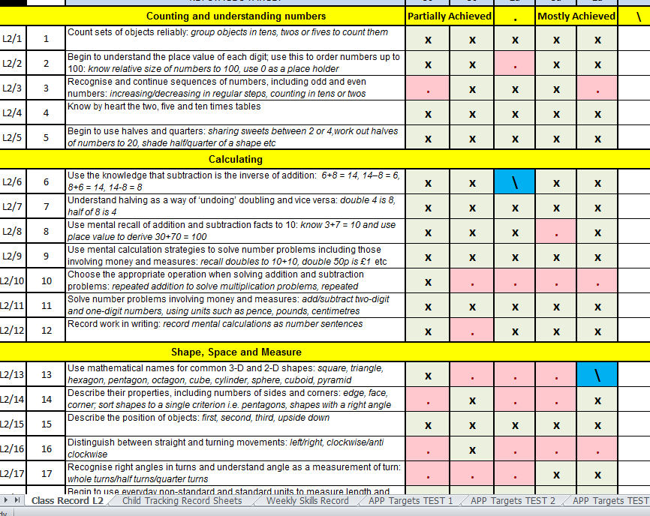

ENGLISH

Each month pupils complete a piece of extended writing known as the Big Write, work is planned by the English subject teacher and delivered weekly by each class teacher during the timetabled Big Write session. The English subject teacher provides work and resources for one week of taught and planning time and once week for extended independent writing.

Marking and Feedback of Big Write work takes the form of Red (R), Yellow (Y), Green (G) which equates to dot, line & cross – against each of their targets. There is a space at the bottom of the feedback sheet for more detailed written feedback. Pupils receive their own big write tracking sheets for all extended writing tasks, this allows pupils and staff to target areas of weakness in their writing and also to challenge pupils to maintain high standards.

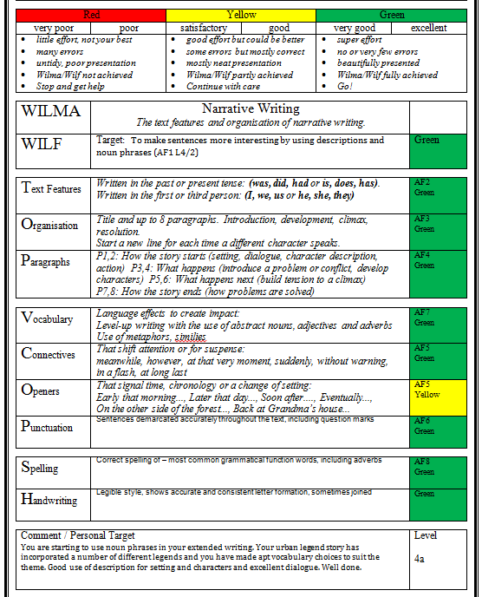

Marking and Feedback
The same colour code system used in mentoring is also employed in daily feedback and marking. It provides children with a visual indication of performance and judgements and makes marking more focussed yet simpler.

Red |  | Yellow |  | Green
very poor | poor | satisfactory | good | very good | excellent
- little effort, not your best  - many errors  - untidy, poor presentation  - Wilma/Wilf not achieved  - Stop and get help |  | - good effort but could be better  - some errors but mostly correct  - mostly neat presentation  - Wilma/Wilf partly achieved  - Continue with care |  | - super effort  - no or very few errors  - beautifully presented  - Wilma/Wilf fully achieved  - Go!

Pupil Personal Literacy Target
The teacher sets targets for the pupil for the whole of the next half term by going to the lines on the pupil tracking sheet. This is because the pupils are closest to converting these into crosses already. The Literacy target are referred to regularly and can be found on pupils Personal learning Plans (PLPs) and termly pupil assessments which are shared with home.

Big Write Tracking Record sheets are for the teacher to easily and continually track pupil progress without having to refer to individual exercise books. They allow the teacher to maintain an overview of class performance and are particularly useful in identifying gaps in teaching or learning, which in turn informs planning. They also give an indication of ability groups to inform class organisation and differentiation and show the children requiring intervention and extension work. The teacher can see what impact his/her teaching has had. They use these assessments to change what was planned to teach. Now teaching to the gaps in learning identified by the assessments. The scheme isn’t abandoned but is modified to address gaps in pupils’ learning. We teach the pupils…not the scheme.

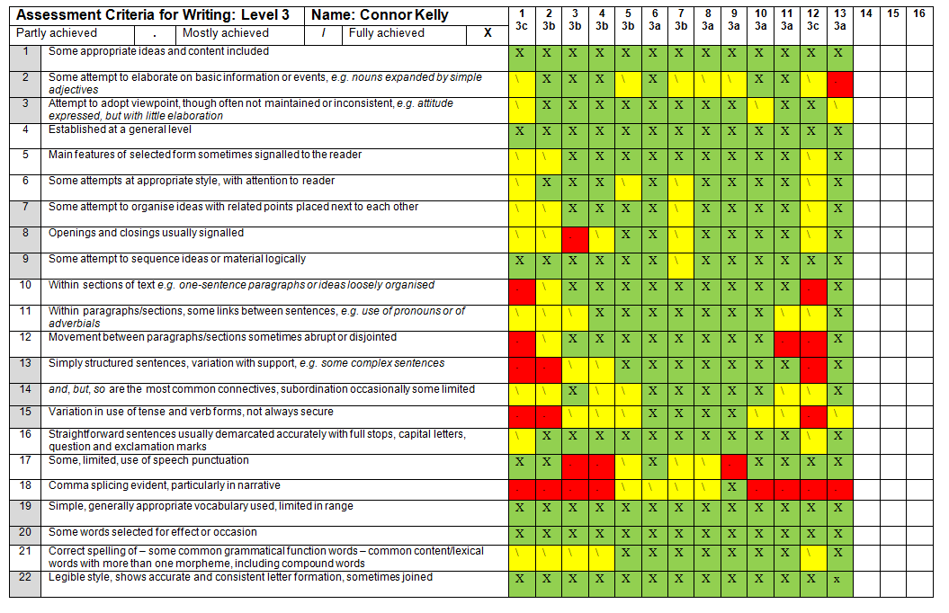

Pupil Prompt Sheets are used during big write, in English lessons and in the Learning Resource Centre (LRC) when teaching pupils to level up their vocabulary. Staff teach to the prompts so that pupils are hearing the words we expect them to begin using in their writing regularly.

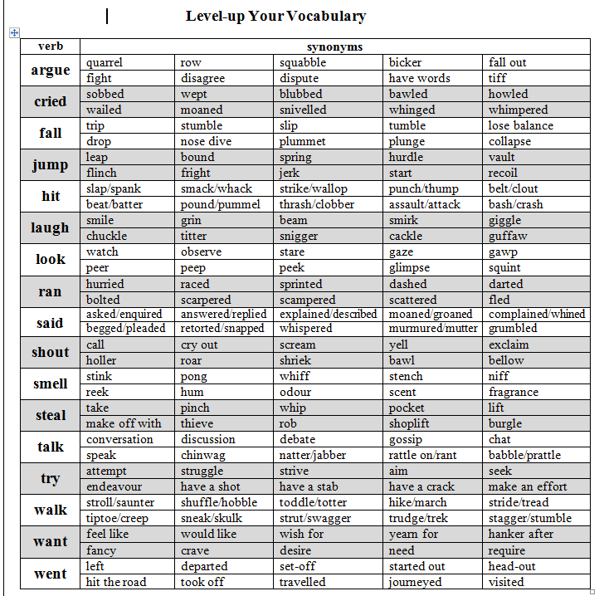

RESPONSIBLITIES OF THE MATHS/ENGLISH SUBJECT TEACHERS

Need to do

- Set medium term targets towards achieving the long term targets
- Set short term targets towards achieving the medium term targets
- Teachers use evidence and target setting to identify interventions
- Check that interventions are in place
- Give feedback/support on their effectiveness
- Feedback and discuss findings/observations with AMSL
- Communicate the end of key stage targets to SLT, pupils and parents
- Set learning targets to enable pupils to achieve end of year targets
- Measure pupil progress towards end of year targets at regular intervals
- Update pupils on progress towards end of year targets
- Identify children for specific interventions to deal with under-achievement
- Communicate targets to teaching assistants
- Check on intervention effectiveness – suggest any changes

What do they get out of it?

- Assessments to inform practice and improve teaching and learning styles
- Excellent professional development
- Effective support from teaching assistants
- Successful team work
- Team highly focussed on raising standards
- Department hitting targets
- A sense that school leadership and systems are focussed on supporting them
- Personal satisfaction and success
- More motivated pupils
- Pupils reaching targets
- Sense of school leadership and systems focussed on supporting the teacher
- Personal satisfaction and success

PUPIL MENTORING FILES
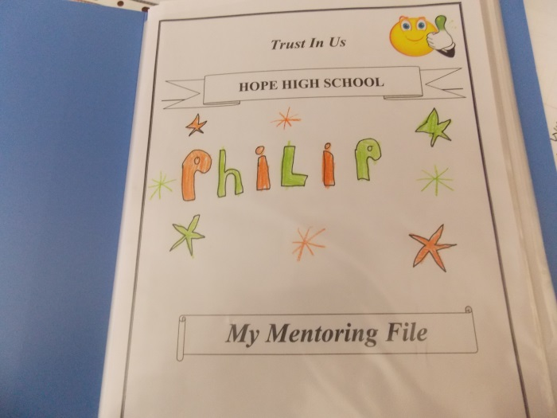
Each pupil has their own mentoring file which is a source of evidence for their own achievement and progress. Mentoring files are set up by the class teacher but the pupil is encouraged to take ownership of their files and ensure that is remains up to date. The pupil also takes their files with them to their mentoring meetings to aid collaborative discussion about their progress.

Each Mentoring File Includes

Attainment, Achievement and Attitude
- Tracking, Targets, Progress
- Grading Key
- Certificates / Awards
- Record of Achievement
- Report Record KS3/4 Pupil Assessments (IEPs)
- Risk Assessments

Maths
- Assessment Criteria and Performance
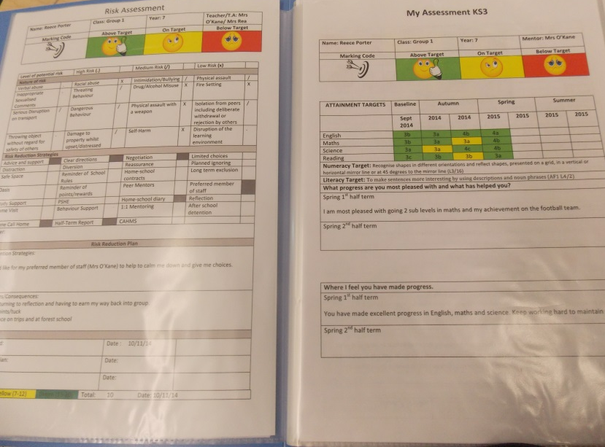
- Scheme Progression
- 3most recent weekly skill test
- Half Termly / Weekly Maths Record
- Big Maths intervention work

English
- Assessment Criteria and Performance
- Extended Writing Evidence / Feedback / Targets
- Key Word (Spell) Tracking (if appropriate
- Grammer Hammer Intervention/Support Records

MONITORING AND EVALUATING PROGRESS

CONTINUAL ASSESSMENT

The success of Assertive Mentoring depends on continual assessment which is:
- Consistent
- Accurate
- Simple to gather
- Simple to record
- Universally understood
- Able to generate relevant medium term targets

LONG TERM TARGET SETTING
To ensure aspiration in target setting we set expectations for progress as:

- 3 sub stages of progress per academic year

If progress has exceeded personal targets the end of year targets can be raised. If progress has been poor, targets may be dropped, but only by the SLT. Even here, the aspiration in the system still allows 3 sub stages progress to be achieved in nearly all cases and targets can never be dropped below FFT Aspire predictions.

APS | NC Level | Old Expect | New PoS | Banding | 16 point progress
1 | WC | N |  |  | N1
2 |  | N
3 | WB | N |  |  | (+4)
4 |  | N
5 | WA | YR | Stage 0 | St 0 Emerging | N2
6 |  | YR | Stage 0 | St 0 Developing
7 | 1C | YR | Stage 0 | St 0 Securing | (+4)
8 |  | YR | Stage 0 | St 1 Ready
9 | 1B | Y1 |  |  | R (1B)
10 |  | Y1 | Stage 1 | St 1 Emerging
11 | 1A | Y1 | Stage 1 | St 1 Developing | (+4)
12 |  | Y1 | Stage 1 | St 1 Securing
13 | 2C | Y2 | Stage 1 | St 2 Ready | Y1 (2C)
14 |  | Y2
15 | 2B | Y2 | Stage 2 | St 2 Emerging | (+4)
16 |  | Y2 | Stage 2 | St 2 Developing
17 | 2A | Y3 | Stage 2 | St 2 Securing | Y2 (2A)
18 |  | Y3 | Stage 2 | St 3 Ready
19 | 3C | Y3 |  |  | (+4)
20 |  | Y4 | Stage 3 | St 3 Emerging
21 | 3B | Y4 | Stage 3 | St 3 Developing | Y3 (3B)
22 |  | Y4 | Stage 3 | St 3 Securing
23 | 3A | Y5 | Stage 3 | St 4 Ready | (+4)
24 |  | Y5
25 | 4C | Y5 | Stage 4 | St 4 Emerging | Y4 (4C)
26 |  | Y6 | Stage 4 | St 4 Developing
27 | 4B | Y6 | Stage 4 | St 4 Securing | (+4)
28 |  | Y6 | Stage 4 | St 5 Ready
29 | 4A |  |  |  | Y5 (4A)
30 |  |  | Stage 5 | St 5 Emerging
31 | 5C |  | Stage 5 | St 5 Developing | (+4)
32 |  |  | Stage 5 | St 5 Securing
33 | 5B |  | Stage 5 | St 6 Ready | Y6 (5B)
34
35 | 5A |  | Stage 6 | St 6 Emerging
36 |  |  | Stage 6 | St 6 Developing | (+4)
37 | 6C |  | Stage 6 | St 6 Securing
38 |  |  | Stage 6 | St 7 Ready
39 | 6B
40
41 | 6A
42
43 | 7C

MEDIUM TERM TARGETS
The assessment criteria on the class and pupils records are replicated on individual mentoring records. This allows for easy transference of attainment and progress information in preparation for the mentoring meeting. The same code is used to indicate partly, mostly, fully achieved and is understood by children.

Discussion between staff and pupils will focus around the assessment criteria which is already mostly achieved ( / ) and what is required for it to become fully secure (X). Once it is clear that the child understands the criteria and what is required, they will become the child’s personal and medium term targets for that subject and form the basis of marking, feedback, assessment and support if required. If pupils demonstrate full understanding and mastery of the criteria, the teacher awards a cross on the pupil’s tracking sheet; if only partial ….a line; completely wrong…. a dot.

Partly achieved | . | Mostly achieved | / | Fully achieved | X

This code allows the teachers’ class records to be updated by overwriting from a dot, to a line, then a cross to provide a continual record of current performance.

This is printed and given to the pupils as their record. It is re-printed for pupils every half term after each new half termly test results in an update. That is why there are six columns. A clear picture builds over the year, increasing the evidence base and therefore teacher confidence in the accuracy of the level assigned.
Half Term Reports – Pupil Assessments

Pupil Self-Assessment and Peer Assessment
The school has several systems which facilitate pupil and peer assessment. For mentoring purposes the child tracks their own progress towards targets and completes the self assessment sheet before the mentoring meeting. It is then compared with the evidence base in order to challenge or confirm perceptions of performance and behaviour.
This is particularly useful for revealing potential barriers to learning, challenging excuses and reflecting on the causes and effects of poor attitude and behaviour. The self-assessment sheet also provides the opportunity to celebrate particular successes and comment on the quality of support received.

At the end of each half term pupils and parents/carers receive a KS3/4 Pupil Profile which details individual achievement that half term and previous progress against their own individual targets. Class teachers colour the cells green for working above their target, yellow for on target and red for below. Similarly attitude tracking sheets are completed by class teachers and the results of these are transferred half termly onto the pupil profile.

Attendance, punctuality, behavior and effort, also basic skills work in tutor groups and uniform are also tracked and targets for improvement are set where necessary.

Attitude has profound implications for attainment and achievement. This system visually demonstrates that link and provides powerful evidence to children and parents. Regular attitude tracking provides an effective vehicle for challenging poor attitudes and demonstrating their effects on performance. In turn this becomes a powerful motivator for children.

Attitude | Last year | Term 1 |  | Term 2 |  | Term 3
Attendance | 98% | 95% | 96% | 90%
Punctuality
Behaviour
Effort
Homework
Uniform

In the above example it is clear that punctuality, behaviour and uniform are very good. Effort has improved on the autumn term. Attendance and homework completion, though satisfactory have slipped in the first half of the spring term. These will form the basis of specific attitude targets and support where necessary.

PROGRESS MEETINGS
The primary focus of mentoring sessions, targets and support is driving achievement. After each half termly mentoring sessions are completed, a full staff progress meeting is held to evaluate pupil progress and identify any pupils who either have excelled through intervention and can now engage in class independent or those who require additional support. The assertive mentoring files and assessment data provide an instant visual representation that all, including children, understand. It clearly indicates where a child is doing well, where care needs to be taken and where additional support is required.

PUPILS

What do they need?

- End of year/ key stage targets
- Regular feedback on progress towards these
- A consistent recording system for this which children understand
- Learning targets set by teachers to enable reaching end of year targets
- Effective interventions to break down barriers to their learning
- Regular mentoring (termly) and access to additional mentoring if needed
- To know they’re being checked on

Need to do

- Help negotiate medium term targets
- Know their agreed targets
- Record progress towards meeting these targets (self assessment)
- Attend mentoring meetings
- Trust their mentors and discuss learning issues with them
- Be prepared to be challenged
- Comply with agreed interventions

What do pupils get out of it?

- 1:1 attention from teacher and TA
- Clear guidance on what and how to improve
- Support to help improve
- Removal of barriers to learning
- Strengths recognised
- Regular, ongoing and quality feedback about progress
- The motivation of knowing what levels will be achieved progress is maintained
- Fulfilment of potential

ROLES AND RESPONSIBILITIES

SLT RESPONSIBILITES

It is the responsibility of SLT to ensure tracking systems are in place and are being used and that
mentoring sessions are timetabled to provide opportunities to ensure that mentors meet with pupils. The SLT will also provide training and guidance to develop mentors. SLT will also identify which barriers to learning are ‘whole school’ in nature and recommend to Head Teacher that these are dealt with in the school’s Action Planning. The SLT will support and challenge teachers, offering advice on how to make interventions more effective and ensure that this advice is acted upon

What do the SLT get out of it?

- A means to develop SLT members leadership skills
- A means to manage team leaders effectively keeping them focussed on standards
- An unrelenting focus in the school on raising standards of achievement
- Ensuring pupils receive personalised learning

TEACHER RESPONSIBILITIES

However after the Progress meeting all teaching staff are responsible for acting upon advice key messages in the data and the type of interventions that should be considered. Teachers must ensure that pupils know their personal targets and are provided with plenty of opportunity to strive to achieve these. Teachers must take appropriate action if pupil/s progress remains below expectations. Teachers are expected to discuss the effectiveness of interventions with colleagues formally and informally particularly during whole school progress meeting. Giving feedback to the SLT about impact of interventions and the use of rewards and sanctions as appropriate.

WHAT DO TEACHER INTERVENTIONS LOOK LIKE?

- Changing teaching style for individual pupils
- Alter the use of resources
- Provide pupil prompts for planning, checking and self -assessment
- Regular and focussed feedback on agreed targets
- Relevant basic skills work is provided
- Complete all report and data tracking forms

Attitude’ is carefully tracked at least termly. This includes attendance, punctuality, behaviour, effort, homework and uniform. Each area is colour coded: Green-excellent/very good, Yellow-acceptable/satisfactory, Red-unacceptable. Targets and support are agreed where necessary

The child’s individual records are expected to be transferred to a class record to provide an overview of class performance, which should in turn inform planning teaching, pupil groupings, differentiation etc. As they completed under test conditions they can be used; to help confirm or challenge judgements; to identify those requiring additional support; to assist with target setting and to inform teaching.

MENTOR RESPONSIBILITIES

Mentors have the responsilibility to check that mentoring meetings are effective, a change of pupil mentor may be required if the relationship isn’t working.

Assertive Mentors project confident body language matching the messages given. They are prepared for meetings and know their children well. They genuinely consider others perspectives but are not deflected from finding a way forward. Children learn that their mentors actually want them to succeed, believe that they can and will help them do it. This proves a powerful motivator and helps to build self belief and a culture of success.

MENTORING MEETINGS

Mentoring meetings can have huge impact. They can leave the child with a clear knowledge of where they are; where they could or should be; what they need to do next; the timeframe in which this is to be achieved and how the school intends to help.

This can prove truly motivational for many children. It lets them know the purpose of the teaching and learning activities to come; the relevance of any support and associated homework they receive and makes targets meaningful and individual. This can result in true personalised learning.

The mentoring meetings also provide the perfect opportunity to gain a deeper insight of the whole child; to build meaningful and positive relationships; to establish trust and mutual respect; to identify and systematically remove barriers to learning; to inform planning, groupings and support and to reflect and improve on your own practice.

The time and effort which goes into individual consultations signals the high status of the activity and the value of the individual. Mentoring meetings can also be an expensive waste of time and energy. The impact will be determined by the quality of the meetings. Ensuring successful mentoring meetings is therefore critical.

PREPARATION

Before the meeting THE MENTOR must:
- Have the child’s latest assessments
- Update the child’s criteria sheets using the agreed code
- Total the criteria achieved and assign a level and sub-level
- Update the tracking with levels and sub-levels
- Colour code progress red, yellow or green against the child’s targets
- Ensure other records (intervention, big maths, key words, smiley cards etc) are up to date
- Liaise with TAs and other agencies working with the child regarding attainment, achievement and attitude
- Ensure all rewards, certificates and sanctions are present and up to date
- Ensure you have attendance figures for the half term.

Before the meeting THE MENTOR should have:
- Precise knowledge of how the child has performed regarding attainment and progress
- A clear idea of what the child’s next targets should be
- An understanding of the rate of progress (therefore number of targets) needed to make the progress required
- A clear idea of what support may be required and is available.

Before the meeting THE MENTOR should not:
- Pre-populate the child’s target sheet

Before the meeting THE CHILD should have:
- A clear idea of what to expect
- A good understanding of the marking and colour codes
- The opportunity to review their mentoring files and latest assessments
- Have completed a self-assessment of their progress

Check that mentoring meetings are:-

- Taking place and on time: timetabled, supported with release time
- Not too time consuming: feedback from mentors
- Productive: children know their targets. Tracking sheets show pupils on target
- Followed up with additional meetings where necessary: SEN, intervention, parents, SLT

KEY PRINCIPLES

- Mentoring meetings are scheduled, guaranteed and regular
- The meetings have a direct interventionist style, offering strategies and negotiation but making assertive demands in return
- Pupils feel that the conversation will be business like and have positive benefits
- It is a “single”, ongoing conversation
- It is never a “cosy chat”
- The conversation is evidence driven
- It has clear outcomes and agreed interventions
- Pupils are left in no doubt that they MUST carry out the interventions because checks are made.

What do they need?

- An assessment system which informs medium term target setting and intervention
- A bank of potential subject relevant interventions
- Time to conduct the intervention sessions
- Pupils’ medium term targets
- Guidance on how to use the targets to inform practice
- Time to meet with teachers and agree short term targets
- Agreed assessment criteria in a consistent and manageable form
- Support in becoming confident in assessing against the criteria

Need to do

- Set short term learning targets to enable pupils to achieve medium term targets
- Communicate short term targets to pupils
- Measure pupil progress towards medium term targets at regular intervals
- Update pupils on progress towards achieving targets
- Communicate progress to teachers
- Update ongoing records in preparation for mentoring meetings
- Check on intervention effectiveness – suggest any changes

What do they get out of it?

- Assessments to inform and improve practice
- Excellent professional development
- Sense of worth in achieving individual and school targets
- Performance management success
- More motivated pupils
- Pupils reaching targets
- Sense of school leadership and systems focussed on supporting them
- Personal satisfaction and success
LEARNING RESOURCE CENTRE

EFFECTIVE INTERVENTIONS

In the Learning resource centre pupils are provided with targets individualized support in a nurturing environment and small group setting. The key to pupils reaching their aspirational targets is the quality of the interventions that are successfully implemented to BREAK DOWN THEIR BARRIERS TO LEARNING and correct under-achievement early. The right interventions are identified through Assertive Mentoring and systematic school screening and continual assessment.

- Focussed teaching on precise areas of need
- Additional small group or individual support
- Providing feedback on progress to pupils in one to one conversations
- Changing interventions when necessary
- Letting teachers know about the problems pupils are having accessing learning in their classrooms and what to do about it
- Arranging ‘extra teaching’ for pupils who are having difficulties
- Constantly monitoring the effectiveness of interventions through tracking

PARENT PARTNERSHIP

One of the main benefits of Assertive Mentoring is the consistent, evidence-based judgements it presents to parents and guardians regarding attainment, achievement and attitude and the often clear impact that one can have on another.

PARENTS – support the school’s interventions by:-
- ensuring good attendance and punctuality
- ensuring adherence to the uniform policy
- ensuring the completion and return of all homework
- attending Assertive Mentoring meetings
- contacting the mentor for feedback about their children’s progress
- checking that their children are complying with the interventions
- getting feedback from their children
- passing feedback on to the school
- applying rewards and sanctions as appropriate
- ensuring that their children understand that the school has their full backing

What do they need?

- End of year end of key stage targets and levels
- Feedback on child’s progress towards targets
- Understanding of the interventions put in place
- Easy access to mentors
- Advice on using effective rewards and sanctions at home
- Reassurance and support

Need to do

- Contact mentors for progress checks
- Check tracking data for progress
- Discuss the data with child
- Comply with mentors’ requests re-interventions
- Apply rewards and sanctions as appropriate at home

What do they get out of it?

- Knowing that the school has set aspirational targets from the outset
- Regular, quality feedback on child’s progress
- The opportunity to support or challenge their child with confidence
- Advice about effective interventions from mentors
- Genuine partnership between home and school
- De-personalises potential conflict with child
- My child succeeds!

