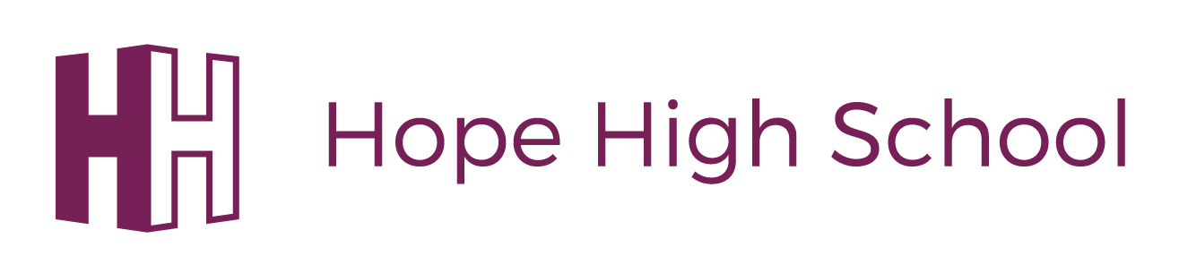
Speech and Language support at Home High School

In the last 12 months 33 pupils have accessed support to develop their communication skills.
We have RAG rated the results of the school whole school language assessment which was completed in November 2018.
Red - below expected progress =12%
Yellow - on expected progress =42%
Green - above expected progress = 46%
Those pupils in the red category will be provided further targeted 1:1 support moving forward.

