COLLEGE OPEN DAYS

TUESDAY 1 OCTOBER, 4-7.30PM
SATURDAY 2 NOVEMBER, 10AM-2PM
WEDNESDAY 11 MARCH, 4-7.30PM
Tel: 01772 22 50 00
RUNSHAW COLLGE – Leyland Campus
Sept 21st @11 AM-3PM, Oct 14th @4PM-7PM, Nov 19th 4PM-8PM, 4th March 2020@4PM-8PM
Tel: 01772 622677
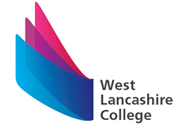
WEST LANCASHIRE COLLEGE – All events are 4:30PM-7PM
Monday 4 November 2019, Thursday 21 November 2019 Monday 10 February 2020, Thursday 11 June 2020
Tel: 01695-52300
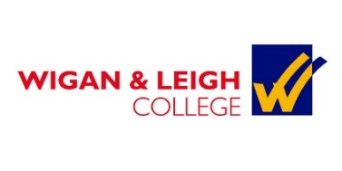
WIGAN AND LEIGH COLLEGE- Wigan Campus
All Days 4:30PM- 7:30 PM -Monday 7th October 2019, Monday 11th November 2019, Monday 3rd Feb 2020 & Monday 27th April 2020
Tel: 01942 761 600
MYERSCOUGH COLLEGE –Course Advice Mornings 10 till 12.30
Saturday 5th October 2019, Saturday 9th November 2019 , Saturday 7th December - 2019 (Please Contact to confirm)
PRESTON SITE Tel-01995 642222 CROXTETH SITE-0151 228 7162

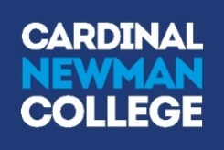
Cardinal Newman College
Sat 12th October 2019, Sat 16th November 2019 Sat 1st February 2020
10am – 1pm Tel:01772 460181
SOUTHPORT COLLEGE
Open Evenings take place in the Main building on Mornington Road from 5.00pm – 8.00pm on: Tuesday 8 October 2019, Monday 25 November 2019, Tuesday 3 March 2020 & Monday 1 June 2020
Tel -01704-500606
St Helens College
Open events take place in the Town Centre Campus and STEM centre from 5:30pm-8:00pm on: Wed 9th October 2019, Thurs 7th November 2019, Wed 5th February 2020
Tel: 01744 733766

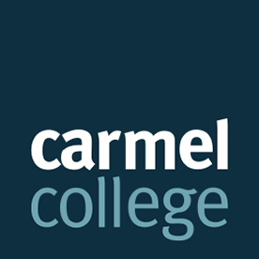
Carmel College
Visit Website to book a place on these open days
Saturday 21 September
Saturday 19 October
TEL: 01744 452 200

Training Providers

CAST Fisheries - 01257 463012

4tech moto training - 01772 759100

Preston Vocational Centre
01772 880680

Skills Construction centre - Kirkham
01772 686868

Pro Co Wigan
01942 318 099

Creativity Works Preston- 01772 555123

Wigan- 01942 74200
Chorley -01257 479900
Preston- 01772 82819

