Hope Post

We are launching the new Hope Post to keep in touch with each other whilst we are all doing our best to stay well and support the NHS.
Social distancing can be difficult and may leave some of us feeling cut off from our normal friendships and routines.
We would love it if you could share some news, ideas, encouragement, humour etc so that we support each other in these times when life can feel very strange.
Send your contributions by email to Ms Houghton, Mrs Baguley or Mrs O’Kane and look for the daily Hope Post on the website. Let’s look out for each other and keep our Hope spirit strong!
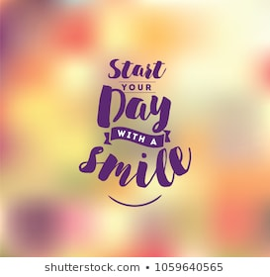
Email: houghtonb@hope.lancs.sch.uk
baguleyc@hope.lancs.sch.uk
okanel@hope.lancs.sch.uk

You might want to think of contributions under the following headings:
- Something new: have you tried a new recipe, taken up a new hobby, played a new game or read a new book? Send an email and let us know so we can share the good news!

- Have your say: have you watched something on the news or read something online that you want to respond to? Email your comments on the topic.

- Make us smile: it could be a joke, funny anecdote, a cartoon – if it will give us a much- needed injection of humour, share it with us.

- Creative challenge: have you written a short story or graphic story? Or written some lyrics or a poem you are proud of? Or maybe painted or sketched something? Or crafted something useful or beautiful? Share it with us! Send your photos or writing so we can all enjoy it.

- Personal challenge: are you using the time to make some healthy lifestyle changes? Maybe you have found a new way of exercising…or trying to make healthier food choices…or trying out mindfulness activities to look after your mental health. Whatever it is, we would love to hear it.

