

Staff Marking Policy

Policy Title | Staff Marking Policy
Version | V2
Committee Approval | SLT
Approved | Yes
Date of Approval | November 2018
Review Frequency | Annually
Review Date | October 2019
Approved By : Headteacher | Helen Dunbavin
Approved By : Chair of Governors | N/A

EQUALITY AND DIVERSITY STATEMENT
Hope High School is committed to the fair treatment of all in line with the Equality Act 2010. An equality impact assessment has been completed on this policy to ensure that it can be implemented consistently regardless of any protected characteristics and all will be treated with dignity and respect.

POLICY REVIEW
To ensure that this policy is relevant and up to date, comments and suggestions for
additions or amendments are sought from users of this document. To contribute towards the process of review, please contact the author of the policy.

Hope High School Marking, Feedback and Assessment Policy
Introduction
The purpose of this policy is to make explicit how teachers should mark pupils’ work and provide
feedback, in addition to how students should ideally present their work.
‘Feedback is one of the most powerful influences on learning and achievement’
(Hattie and Timperley 2007, Review of Educational Research March 2007, Vol. 77, No. 1, pp. 81 – 112)
However, feedback has the power to impact both positively and negatively on pupil performance. To be positively effective …” feedback must answer three major questions asked by a teacher and/or by a pupil:
Where am I going? (What are the goals?),
How am I going? (What progress is being made toward the goal?), and
Where to next? (What activities need to be undertaken to make better progress?)” (ibid p86)

Policy Objective
This policy is based on the principles of constructive feedback to impact positively upon pupil progress.

Policy Outcomes
- To develop marking which is meaningful that leads to increased pupil mastery in the given curriculum area.
- To provide an assessment of pupil learning which is manageable within a teacher’s work load, as well as providing information on an individual’s achievement, attainment, effort and progress.
- To develop pupils’ pride in their work; to motivate and challenge students to take responsibility for and ownership of their work and learning.
Effective marking is a dialogue between teacher and student and brings about progress. The marking of formal assessments is a good indicator of how the students are progressing. However, class work (whether is it undertaken in exercise books, files or on worksheets) helps to provide the stepping stones towards making this progress. It is therefore vital that class work is marked and commented upon accordingly, and that students act on the comments and demonstrate improvement.

All members of staff are expected to be familiar with the policy and to apply it consistently.

What is the purpose of marking and assessment?
- To praise effort and attainment.
- To encourage, motivate, support and promote positive attitudes towards learning.
- To promote higher standards and set challenging, but achievable targets.
- To provide constructive feedback, allowing learners to identify “next steps” and subsequently accelerate progress. This should be done through DIRT tasks when feasible.
- To encourage learners to self-assess and reflect so they develop better independent learning skills.
This should be done through dedicated improvement and reflection tasks when feasible.
- To correct mistakes and offer encouragement.
- To provide information for assessment which informs teacher planning and targeted intervention for pupils.
- To assess pupils’ performance against stated learning objectives.
- To generate data for analysis and help staff plan appropriately and identify gaps in progress.
- To ensure that marking is standardised throughout the school, allowing for greater opportunities for cross‐moderation and simplify reporting systems and information provided to stakeholders.

Why do we need a marking policy?
It is essential that we have a consistent approach to marking and assessment to provide clarity to all stakeholders and to provide constructive feedback to pupils which supports their learning and
engagement. Involving pupils in their own learning, encouraging pride in achievement and developing their growth mind sets, are major foci for our school. Our aim is to re- engage pupils in learning, equip them with the skills and qualifications to widen their future opportunities and close academic and social gaps in their progress due to often disrupted prior educational experiences and undiagnosed special needs. This policy aims to help close the gap between what they can currently do and what we would like them to be able to do.

What are the principles that guide the schools’ approach to marking?
Marking and feedback should:
- Be accessible and understandable to pupils and manageable for teachers.
- Relate directly to the learning objective(s).
- Achieve differentiated learning outcomes
- Involve all adults working with children / young people in the classroom.
- Give recognition and praise for achievement and clear targets for improvement,
development and reflection.
- Allow time for pupils to enter into dialogue with the teacher and respond to the marking/ feedback.
- Respond to individual learning needs.
- Inform future planning and contribute to target setting and expected learning outcomes.
- Be seen by pupils as a positive means of improving and reflecting on learning.

Key elements of the policy:
- Feedback to pupils is ongoing, takes place each lesson and supports pupils in identifying
“next steps”.
- Marking is regular and follows a consistent approach throughout the school.
- All marking recognises what pupils can do, have achieved and what they need to do next.
- Pupils are active participants in their own learning and engage in the marking and feedback process.
- Teachers standardise marking through regular moderation processes.
- Assessment is embedded in the learning programme for every child/young person and contributes to the analysis of data by individual pupil, groups and overall school.
How do we mark pupils’ work?
The school focuses on three forms of marking / feedback:
- Verbal feedback / dialogue (EVIDENCED EVERY LESSON)
We recognise the importance of immediate and on‐going feedback to pupils. The teacher will initially discuss with the pupil how they have met the learning objective and give feedback on specific areas for improvement. This may be simply praise and encouragement or may involve correction/guidance in improving understanding or to extend learning. Children and young people of all ages need oral feedback but this is especially important where there are difficulties with reading or low literacy skills and reading of teacher comments need support.

- ‘Light’ marking (EVIDENCED IN MOST LESSON)
This usually consists of ticks and corrections should be done by teachers/TA’s in the majority of lessons in the course of checking pupils’ understanding against the learning objective of the lesson. Self/peer assessment/marking and checking by the teaching assistant may also be used here. Students should be encouraged to self/peer assess against lesson outcomes/success criteria in red pen in the majority of lessons.

- Formative marking / feedback (FORTNIGHTLY)
Formative assessment should take place every lesson with assessment for learning. This
could be discussion of learning outcomes, incorporation of tasks that allow the teacher to actively and immediately assess development of student understanding, or otherwise. Evidence of formative marking/feedback must be incorporated at least once every fortnight for all other subjects. This promotes accelerated progress and focuses pupils clearly on where they are at, how closely they have met the lesson objective, what they have done well and what the “next steps” should be. Next steps should
link to a task that further solidifies/ develops the student’s understanding and/or allows for reflection by the student on their learning.

Dedicated Improvement and Refection Time tasks should be done at least once fortnightly. Progress students have made in regards to success criteria/learning objectives and outcomes should be indicated by the teacher through comments, and reflected on by students when appropriate. In addition, the associated feedback can be qualitative (comments), quantitative (numerical scores/results) or both. Students are expected to respond to teacher feedback using red pen.

Giving effective feedback to pupils.
Effective marking is a key tool in providing feedback to pupils in order that they are clear in what they can do well and what they need to do to improve. It also forms part of formative assessment which is essential for teachers to refine and hone planning when teaching pupils so that they can swiftly move forward towards desired learning outcomes.
Effective feedback comes under three main headings;
Specific Achievement feedback identifies specific aspects of successful attainment and or progress. This relates directly to the Learning Objective / Pupil self-assessment made by traffic light or learning ladder target set for the individual.
Specific Improvement feedback identifies where mistakes or misconceptions lie and how work can be improved.
Specific Extension feedback identifies where further understanding can be explored, to deepen learning and further extend higher order thinking.
When feedback is specific and provides opportunity for specific response, it enables effective progress to follow.
Feedback should:
- Be positive, specifically identifying what has been done well. (WWW – green pen)
- Identify an area for specific improvement followed up with an improvement task (NS – blue pen) Or
- identify a specific area for deeper investigation/ extension of understanding (NS – blue pen)
- Pupils are expected to respond to feedback using red pen.

Well-constructed feedback tasks prompt effective response from pupils so to improve quality of work or reinforce learning. They should maintain challenge for individual pupils, yet be easily executed and brief in nature, enabling pupils to move forward, and be aware of how they are improving. For example, the challenge within the task may:
- Refine a teaching point to consolidate or reinforce understanding.
- Extend understanding to deepen learning or raise to a higher level of thinking
- Address/explore misconceptions
- Pick up errors if apparent
- Address incomplete work and presentation issues
- Focus a need for practise – e.g. times tables, attention to place value, spellings, punctuation, grammar

Examples of feedback prompts can be found in Appendix 2 pages 8 - 9
When constructing feedback teachers need to consider:
1. Does feedback inform the pupil what they have done well and what they need to do to improve?
2. Relate to planned learning objectives and success criteria?
3. Can feedback be read clearly and understood?
4. Does feedback indicate a next step/improvement in learning?

Marking and feedback must include:
The Learning Objective(s) and/or learning outcomes must be recorded by the pupil and/or
incorporated into handouts with feedback related directly to this/these made by the teacher marking the work.
Learning outcomes/ “I can” statements – students may comment on their achievement of these, but the teacher is to make explicit what the pupil has achieved with their own comment independently or in response to a student’s comment. “What went well” and “Next Steps” comments can be made in self/peer evaluation of work, or directly by the teacher. Student reflection should be encouraged when feasible though, with “Next steps” given by the teacher and linked to DIRT task.

Teachers must record:
“What went well” (WWW) comments in green pen.
“Next steps” (NS) comments in blue pen

Annotation should include:
Ticks when an appropriate point / correct answer has been made (Green). Smiley faces can be used, related to any positive comment when necessary. A comment related to effort or incorporation into an evaluation.

All staff must adhere to the school’s Marking Code (see Appendix 1) as part of the school’s focus on improving literacy.
Literacy underpins the curriculum by developing pupils’ abilities to speak, listen, read and write for a range of purposes, using language to learn and communicate, to think, to explore and organise. Numeracy also underpins the curriculum and is crucial to a student’s ability to function in society, problem
solve and think logically. All teachers in the school are there to support literacy and numeracy and are committed to developing literacy skills
in all pupils with the aim of subsequently improving their progress across the curriculum and equipping them with
the necessary skills for future success

The Frequency and Nature of Pupil Response to Feedback
Work that is marked developmentally requires a response from the pupil.
Developmental marking is most effective when a well-crafted prompt/request for response is given and completed. Pupils need time to develop this skill throughout the school year appropriately.
In each class, effective time must be given to teaching pupils to respond to tasks swiftly. This process will look different developmentally across each year group, increasing with independence and complexity with maturity and skill of pupils.
By the end of Year 7, most pupils should be able to locate, access and execute simple response tasks with support. They should know what they are doing to improve their learning. Likewise, tasks must be effective in improving work, yet brief in execution.
For most pupils, communication of the feedback will be augmented by adults, until developmentally pupils are able to access this independently.

Acknowledgement of response
This should be swift, in line with the marking policy and not ordinarily an open opportunity for a longer dialogue. If greater issues arise then the teacher will wish to address this with the child through another medium than feedback and response.

Role of other adults supporting
Support staff may mark work with groups of pupils with whom they have been working. When this is the case they will follow the guidelines in this policy: to initial work they have supported, identify if work was independent or supported and as appropriate give feedback verbally or through marking. If developmental marking is done then it should follow this policy and be under the supervision of the class teacher.
Supply teachers who carry out work in the school are expected to mark all work in accordance with this policy. This will be given to all new supply teachers as part of the Staff Handbook (welcome pack) on arrival in the school. A copy of this policy can also be found in the class Teacher Files.
Students in school are required to follow this policy as appropriate, however the class teacher is also required to initial marking completed by the student to ensure quality assurance. Teachers will use professional judgment in discussion with the Senior Leadership Team to ascertain whether the marking of all pupils’ work is monitored or a sample.

Assessment
Baseline assessments are completed on entry for all pupils to confirm the information received on transition. For year 7 pupils, assessment is undertaken by the class teacher and HLTA over the first few weeks shaped around the pupil’s needs. Baseline assessments include reading, spelling, English, Maths and Science. Other subjects must be assessed by teachers within the first half-term. Prior attainment information is sought at the transition stage. Referrals to Hope High School are also accepted on the basis of information being provided to the school and following the pupil to ensure appropriate continuum. Missing information / data will be robustly followed up by the Headteacher where there are gaps.
Progress is measured using the following timescales: termly for all subject areas (using teacher identified assessment tools / tasks), every half term for English, Maths and Science (completion of assessed independent work and assertive mentoring assessments). In addition, half termly progress data for each student based on national curriculum objectives and/or specification points taught is collected to evidence pupil progress. Progress is measured by comparing before teaching and after teaching attainment steps, as determined by teachers based on diagnostic, formative and summative assessments.
Reporting on Progress
Reports are produced three times per year (December, March and July). The summer report summarises the whole year in terms of progress and achievement. Reports to Governors are produced termly by the Headteacher, giving headline figures and analysis of data by different cohorts as well as whole group / school.
Presentation of work
Taking pride in work is expected by all pupils at Hope. Staff feedback demonstrates that staff value pupils’ efforts and recognise success. This, in turn, encourages pupils to take pride in their work, improve their presentation and raise their own standards. Therefore, it is expected that:
- all books are well looked after and presented with name, class, subject and teacher clearly written on the front.
- Any graffiti must be removed where feasible and discouraged with written teacher comments when
present.
- Should graffiti be offensive (e.g. include swearing, insults, etc.) the book must be covered if graffiti is on the front, or the comment covered if inside the book, or a new book purchased by the pupil. Pupils
Should do the covering, and not the teacher.
- All work should be dated.
- All work titles should be underlined, and comment made by the teacher when not underlined.
- Margins must be used where applicable. Rulers must be used to draw straight lines and
pencils for drawings. If not, teachers should comment on this to encourage use of rulers in future.
- Blue or black pens must be used by pupils. Other colours may be incorporated in note‐taking and project work at the teacher’s discretion, particularly when important concepts need highlighted or for flow diagrams, concept maps, etc. However, completion of tests must be done in blue or black. Practice examinations should be done in black pen, as this is required by all boards when sitting examinations.
- Cursive handwriting should be encouraged.
Evidence of progress and effectiveness of marking / feedback
Samples of pupils’ work should be copied and filed in the individual pupil’s Assertive Mentoring file every term as evidence of up to date work and how the pupil has responded to feedback in terms of progress made.

How is work standardised?
Hope High school publishes a book scrutiny, planning scrutiny, and lesson observations / learning walks annually. Hope High school is involved in organising Inter school moderation meetings and establishing links, when appropriate, to Partner SEMH schools to ensure that marking is accurate and validated.
Links to other policies:
- Behaviour Policy
- Assertive Mentoring Policy
- Admissions Policy
- Curriculum Statements/Report

Responsibilities
It is the responsibility of the class teachers to ensure that this policy is consistently carried out, including enabling pupils to respond to feedback tasks.
It is the responsibility of all staff working with pupils to ensure the marking code is consistently adhered to across the school
Each subject teacher has the responsibility for monitoring that the policy is being consistently carried out in their subject area.
It is the responsibility of the Assessment Leader (AHT) to liaise with the Subject teachers and to feed back to the Headteacher and Governors on the implementation of the policy, its consistency across the school and the impact it has upon progress.
It is the responsibility of the Headteacher to ensure that effective marking and feedback is monitored and evaluated as part of the quality assurance of teaching and learning across the school.

Equality of Opportunity
All pupils are entitled to have their work marked in accordance with this policy.

SEN and Inclusion
Effective feedback and marking must be accessible to all pupils and will reflect their individual needs and abilities. This may mean writing comments for specific pupils in an accessible colour, it may mean support pupils to read comments, it may mean recording verbal feedback and response. Such requirements should be identified in a pupil's Support Agreement as required.
Monitoring and Evaluation
Monitoring of the policy will be done through work scrutiny led by the Headteacher and SLT leads as appropriate. It will be monitored for whole school consistency and evaluated for impact on pupils’ outcomes.
The Headteacher will also monitor the impact of developmental marking through work scrutiny in all subjects as part of lesson observations to monitor the quality of teaching and learning in the school. This will be triangulated with pupil interviews to ascertain how developmental marking supports them in understanding what they need to do to improve their learning and to make progress.
Work Scrutiny will be used to monitor consistency across the school and impact of the policy on pupil outcomes. A work scrutiny schedule will be used to monitor and feedback will be given to individual teachers.
Evaluation of Feedback and response will be done through the impact on pupil progress, including progress data but also pupil progress meetings.
Policy Review
This procedure has been agreed by the staff and Governors in the Autumn Term 2016 and will be reviewed in line with the school’s cycle of policy reviews, by and in the first instance no longer than Autumn 2017

Date of Review: Autumn 2019
Date of Approval by Governors: Autumn 2018

Appendix 1 – Hope High Marking Code

What does the marking in your book mean?
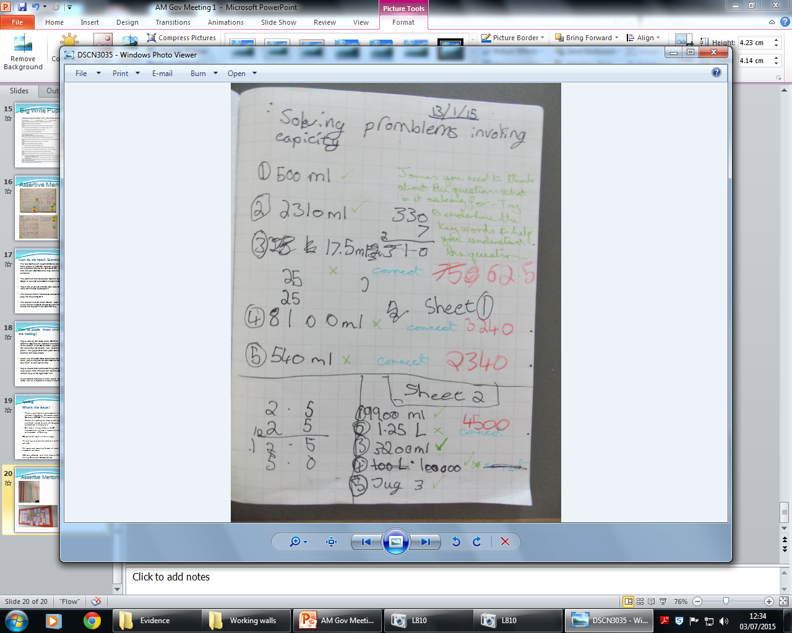
WWW – what went well (green pen)
NS – Next steps in what needs to be done to make more progress (blue pen)
* - you need to act on a comment. E.g. finish something off, correct a
spelling mistake or answer a question. (red pen)
 - Correct
? - Incorrect
sp – Check spelling.


g – Check your grammar e.g. using witch instead of which.
CL – Capital letter needed
p – Check your punctuation e.g. commas, full stops, question marks etc.
^ - A word of letter has been missed.
exp – you could have written this in a better way.
// - paragraphing error/a new paragraph is needed

Appendix 2 Examples of feedback prompts requesting response.

Writing Prompts
Read your work – can you add… (3 full stops, an adverbial which says where, a question mark, etc)
Try to find the sentence which needs to be changed /doesn’t make sense and improve it.
Now try these… (if activity writing about prompts/pictures/adding punctuation/Grammar)
Is there another way you could write this information (highlight sentence)? Is there another way you could do this?
Can you find a way you could write this in a shorter sentence?
Finish this sentence: ….. (Explaining work)
Fill in the blanks: …..
Highlight the sentence where you have used… (adverbials, connectives, correct punctuation, speech marks, persuasive language, etc)
Tell me two sentences that have adverbials.
What ... would you use to…? e.g. What word would you use show me what the character is feeling?
Highlight where you have used (column method, grid method, a strategy to check your answer, etc)
What are the … of … ?

Maths Prompts
Look back at your work – can you add…(your method, a number line)
Tell me two numbers that have a difference of 12.
Fill in the blanks: …. 2 + 6 = 6
What ... would you use to…? e.g. What unit would you use to measure the width of the table?
What are the factors of 42?

Generic Prompts
Can you find where you went wrong?
Now try these… (extension questions/Consolidation questions) If the answer was ….. What could the question be?
Can you find a quicker way of doing this?
Tell me 1/2/3 reasons why I should give you a Wow! Dispatches for this work.
Tell me … that have …?
How could you check this?

References:
The Power of Feedback John Hattie and Helen Timperley REVIEW OF EDUCATIONAL RESEARCH 2007 77: 81
mailto:http://education.qld.gov.au/staff/development/performance/resources/readings/power-feedback.pdf

